# Image result for lebanese university faculty of engineering

Lebanese University

Faculty of Engineering III

Electrical and Electronic Department

# Ahmad Hourani 5992

Fadel Morda 6077

# Fake News Detector

## Introduction

Hey there! Let me tell you about our Fake News Detector project. It's a tool we built to help people figure out if the news they're reading is real or fake. In today's world, where fake news spreads faster than ever, having a tool like this can be really helpful!

## What Does It Do?

Our Fake News Detector is like having a smart friend who reads news articles and tells you if they seem fishy or not. Here's what it can do:

- Read any news article you give it

- Look for signs that might indicate if the news is fake

- Give you a score showing how likely it is that the article is fake

- Explain why it thinks the article might be fake

## How We Built It

We used some cool technology to make this happen:

- A special AI model that's really good at understanding text

- A friendly website where you can paste news articles

- A system that runs everything smoothly using Docker (think of it like a container that keeps all our tools organized)

## The Parts That Make It Work

1. The Brain (Backend)

- This is where the magic happens

- It uses a smart AI model to analyze articles

- It can handle lots of articles at once

- It's built with Python, which is great for AI stuff

2. The Face (Frontend)

- This is what you see and interact with

- It's a clean, simple website

- You can easily paste articles and get results

- It's built with React, making it fast and responsive

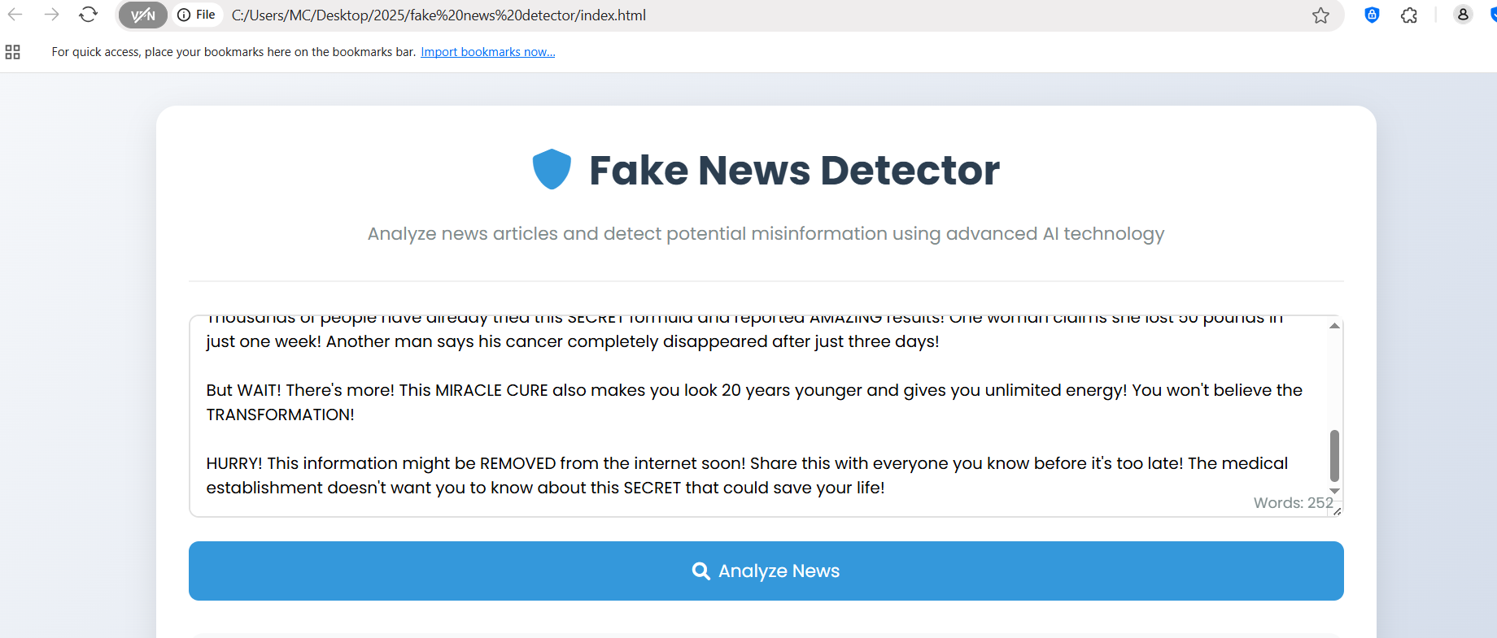

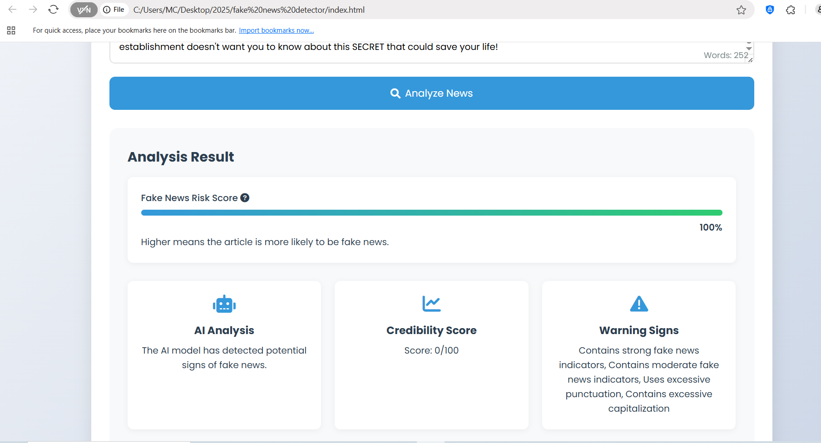

3. The Container (Docker)

- Keeps everything organized and running smoothly

- Makes it easy to set up and run the project

- Ensures everything works together nicely

## How to Use It

Using our Fake News Detector is super easy:

1. Go to the website

2. Copy and paste a news article you want to check

3. Click the analyze button

4. Get your results with explanations

## What Makes It Special?

- Easy to Use: No complicated setup needed

- Fast Results: Get answers in seconds

- Explains Its Thinking: Doesn't just say 'fake' or 'real' - it tells you why

- Always Learning: The AI model keeps getting better at spotting fake news

## Real-World Impact

This tool can help:

- Students doing research

- Journalists fact-checking stories

- Anyone who wants to be more careful about what they believe

- People who want to share news responsibly

## Future Improvements

We're always thinking about ways to make it better:

- Adding support for more languages

- Making it even faster

- Adding more detailed explanations

- Supporting different types of news formats

## Conclusion

Our Fake News Detector is more than just a tool - it's a step towards helping people be more careful about the news they read and share. In a world full of information, having a way to check what's real and what's not is super important. We hope this tool helps people make better decisions about the news they consume and share.

## Technical Details (For the Curious)

- Backend: Python with FastAPI

- Frontend: React with TypeScript

- AI Model: Fine-tuned BERT model

- Containerization: Docker

- Database: SQLite for storing results